**Front-end:**

**VUE Framework:**

“Vue is a progressive framework for building user interfaces. Unlike other monolithic frameworks, Vue is designed from the ground up to be incrementally adoptable. The core library is focused on the view layer only, and is easy to pick up and integrate with other libraries or existing projects. On the other hand, Vue is also perfectly capable of powering sophisticated Single-Page Applications when used in combination with [modern tooling](https://vuejs.org/v2/guide/single-file-components.html) and [supporting libraries](https://github.com/vuejs/awesome-vue#components--libraries).”

**Source Code:**

All the original code of the project is stored in the “**src**” file, which mainly contains four parts: “**assets**” - which contains the pictures and graphs used in the web system, “**components**” and “**views**” - which contain the main web page source code, “**router**” - which records every path of links used in the system, the last component “**main.js**” which imports the package and basic URL address.

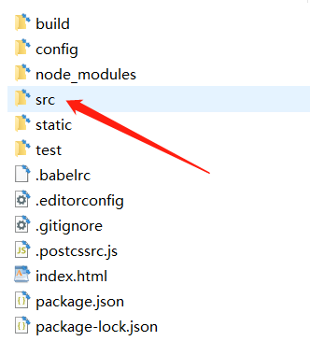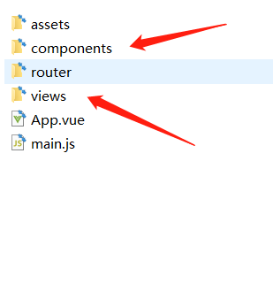

**VUE Coding Structure:**

* <template></template> - the “vue-html” coding.
* <script></script> - import components, return data and JS coding
* <style></style> - the css coding.

**Related Vue File:**

* Homepage: homePage.vue, Index.vue
* Signup Page: Signup.vue, Index.vue, FooterBox.vue
* Login Page: Login.vue, Index.vue, FooterBox.vue
* Browse Jobs Page: BrowseTask.vue, TaskCard.vue, LoggedInHeader.vue
* Job Detail Page: JobDetail.vue, Index.vue, LoggedInHeader.vue
* Supplier Dashboard Page: Dashboard.vue, Jobcard.vue
* Profile Page: updateCard.vue
* Job Status Page: JobStatus.vue, JobStatusCard.vue
* Message Page: Message.vue, Index.vue, LoggedInHeader.vue

**Back-end:**

**Django framework:**

Django is a high-level Python Web framework that encourages rapid development and clean, pragmatic design. Built by experienced developers, it takes care of much of the hassle of Web development, so you can focus on writing your app without needing to reinvent the wheel.

**Source code:**

Here is our whole back-end product

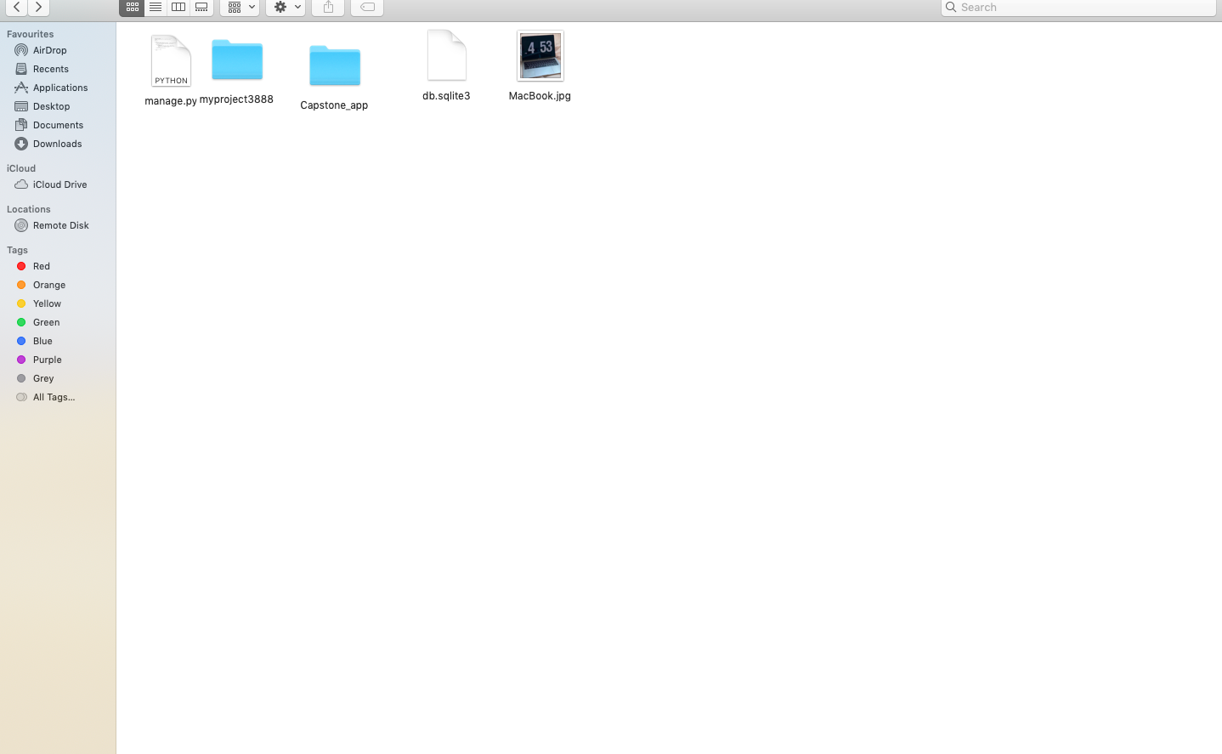

All function source code in Capstone_app file 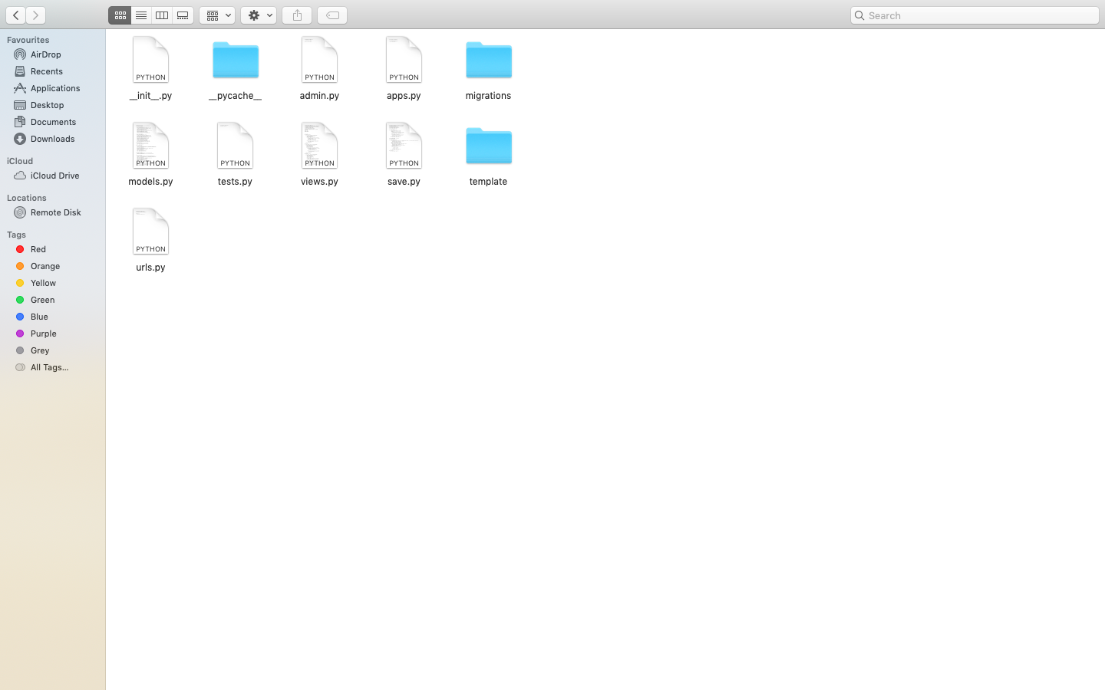

model.py include database model code

view.py include main function code

save.py is used to back up the code in the view to facilitate modification

The setting and path files of the entire framework in myproject3888 file

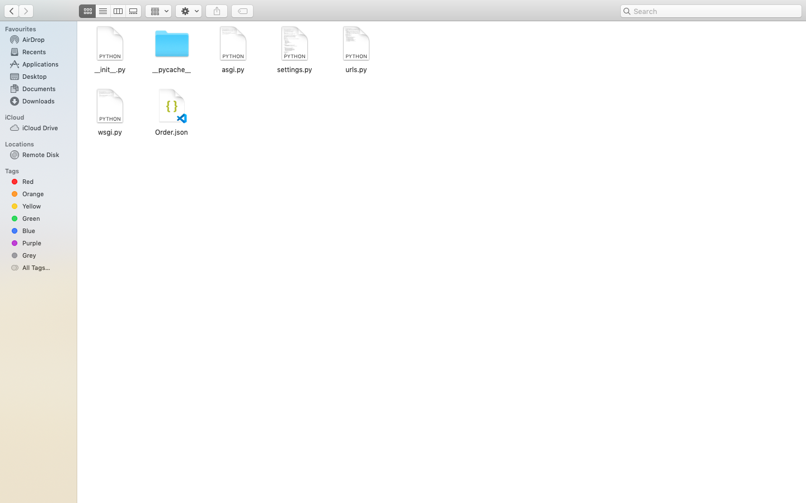

Modify framework setting in setting.py

Modify path and URL in urls.py

Order.json record some test data for our web application

**Function in view.py**

Login section: login_site(), login_cof()

Sign-up section: signup_site()

Message section: createMessage(), initial_message(), get_message(),new_messages()

Order section: createOrder(), get_order_profile(), get_all_job()

Quote section: save_quote(), createNewOrder(), createQuote()

Dashboard section: notification_site(), update_profile()